Task 2-CI Pipeline Using Jenkins

Step 1 — Jenkins Setup:

Install the jenkins using docker:

docker run -d \
--name jenkins \
--user root \
-p 8080:8080 \
-p 50000:50000 \
-v jenkins_home:/var/jenkins_home \
-v /var/run/docker.sock:/var/run/docker.sock \
-v /usr/bin/docker:/usr/bin/docker \
jenkins/jenkins:lts

Step 2 — Add DockerHub Credentials in Jenkins:

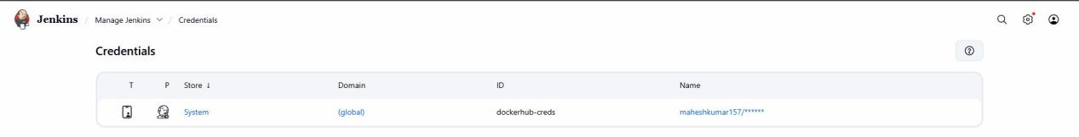

Step 3 — Install Trivy (Security Scanner):

sudo apt install wget -y
wgethttps://github.com/aquasecurity/trivy/releases/latest/download/trivy_0.45.0_Linux-64bit.deb
sudo dpkg -i trivy_0.45.0_Linux-64bit.deb

Step 4 — Add a Simple Test Script:
Inside your Node.js project:

Create the file in the name of test.js and paste the below mentioned content:

console.log("Running basic test...");
console.log("Test passed!");

Step 5-Create the respository in the github and push your code files using the below mention code:

Inside your project folder:

git init
git remote add origin https://github.com/Maheshmak22/Devops-Task.git
git add .
git commit -m "DevOps assignment: Task 1 and Task 2 completed"
git branch -M main
git push -u origin main

Provide username and PAT token to complete the push.

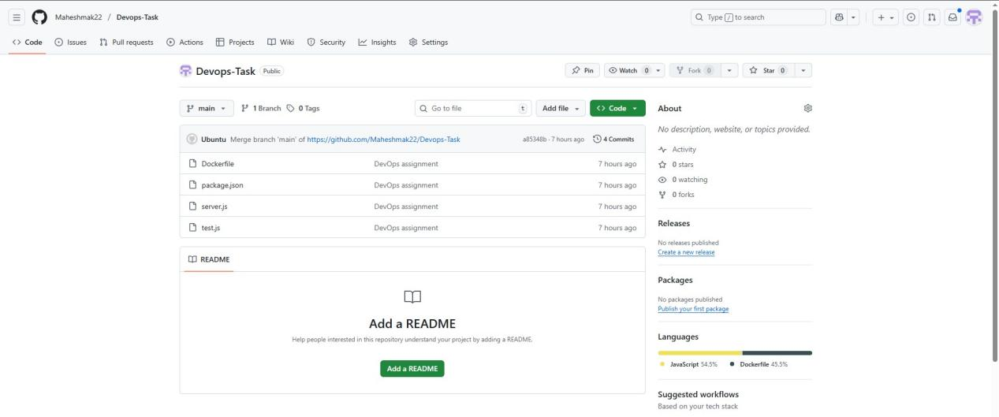

Step 6 — Create Jenkinsfile

pipeline {
agent any

environment {
DOCKERHUB_USER = 'maheshkumar157' // change
IMAGE = "${DOCKERHUB_USER}/node-sample-app"
CREDS = credentials('dockerhub-creds')
}

stages {
stage('Checkout') {
steps {
git branch: 'main',
url: 'https://github.com/Maheshmak22/Devops-Task.git'
}
}

stage('Build') {
steps {
sh 'npm install'
}
}

stage('Test') {
steps {
sh 'npm test'
}
}

stage('Docker Build') {
steps {
sh 'docker build -t $IMAGE:$BUILD_NUMBER .'
}
}

stage('Security Scan') {
steps {
sh 'trivy image --exit-code 0 $IMAGE:$BUILD_NUMBER'
}
}

stage('Login to DockerHub') {
steps {
sh "echo ${CREDS_PSW} | docker login -u ${CREDS_USR} --password-stdin"
}
}

stage('Tag & Push') {
steps {
sh '''
docker tag $IMAGE:$BUILD_NUMBER $IMAGE:latest
docker push $IMAGE:$BUILD_NUMBER
docker push $IMAGE:latest
'''
}
}
}

post {
success {
echo "Pipeline completed successfully!"
}
failure {
echo "Pipeline failed!"
}
}
}

Step 6 — Create a Pipeline Job in Jenkins

In Jenkins, click New Item and select Pipeline as the job type.

Under the Pipeline section, choose Pipeline script from SCM.

Select Git and enter your GitHub Repository URL.

Ensure the repository contains a Jenkinsfile, or paste your pipeline script directly into the Jenkins UI if using Pipeline script mode.

Click Save, then click Build Now to run the pipeline.

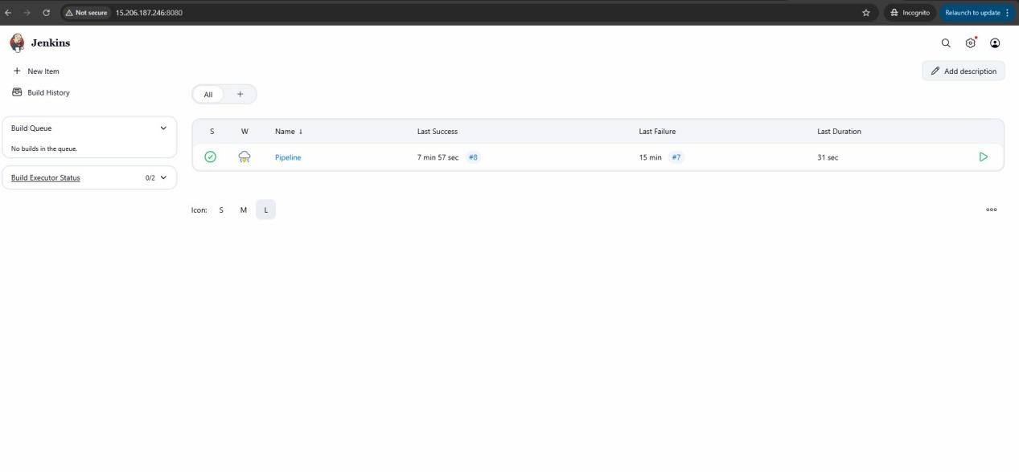
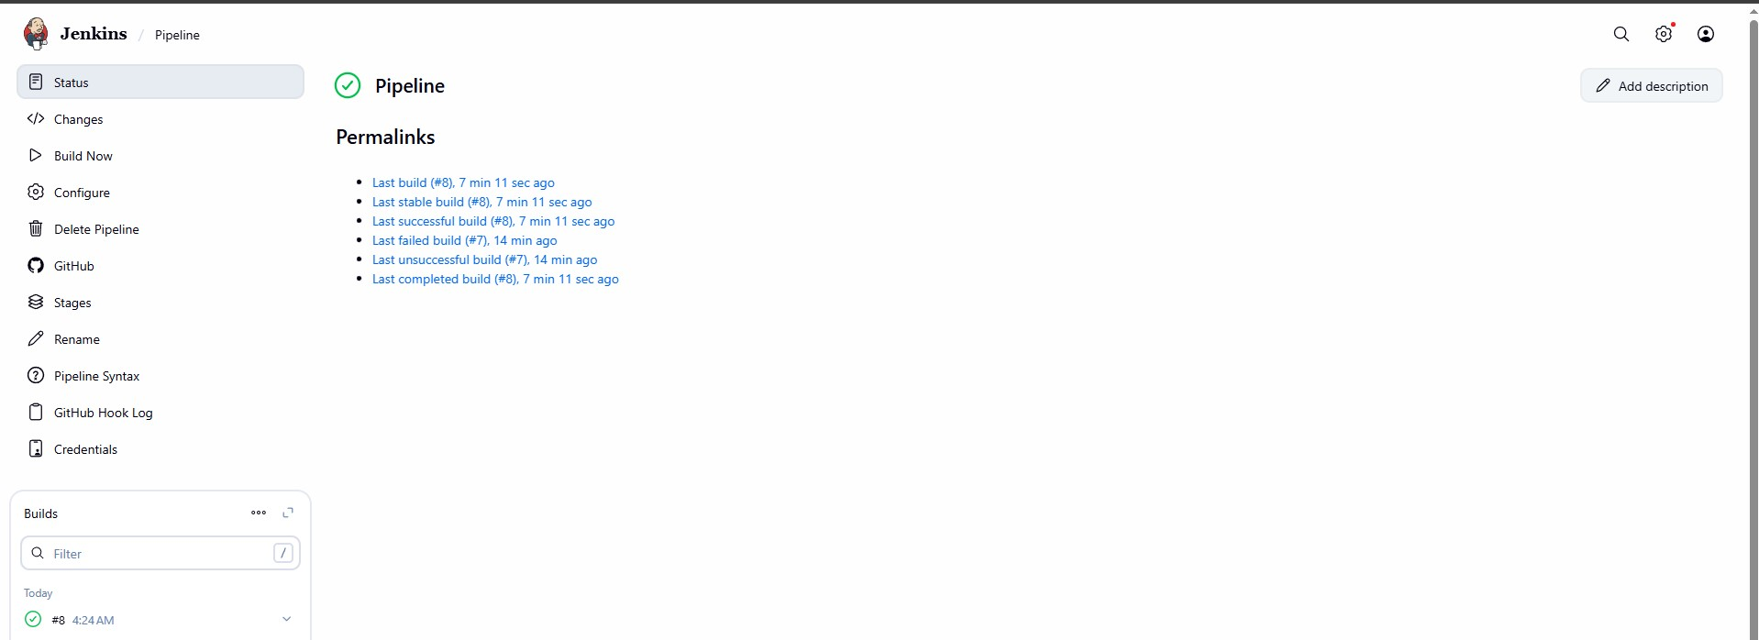

Console Output:

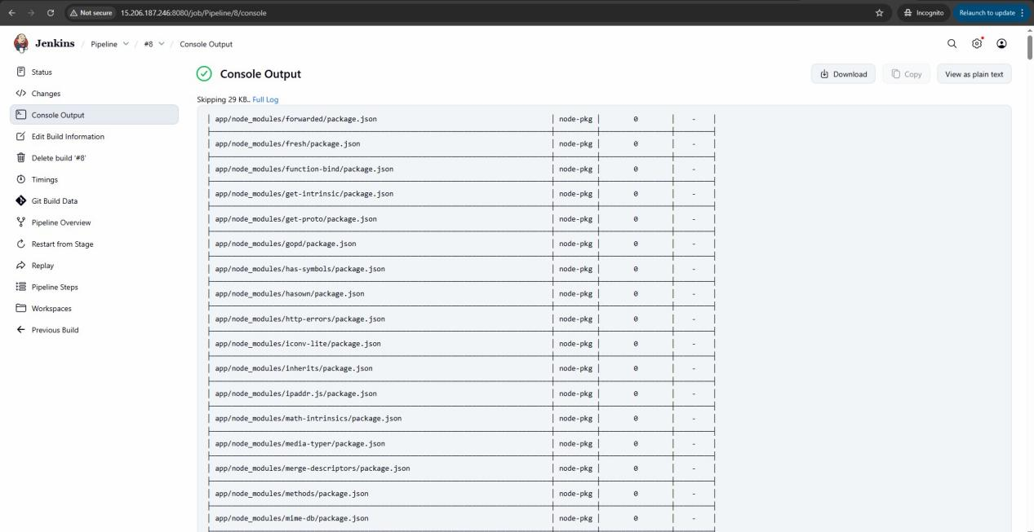

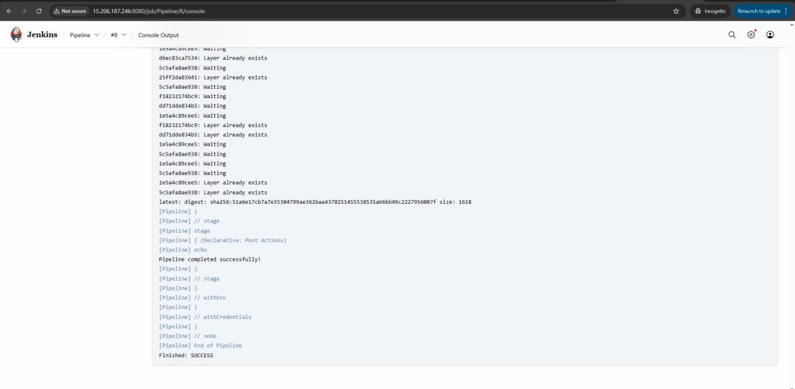

Jenkins pipeline successfully pushed the Docker image to Docker Hub:

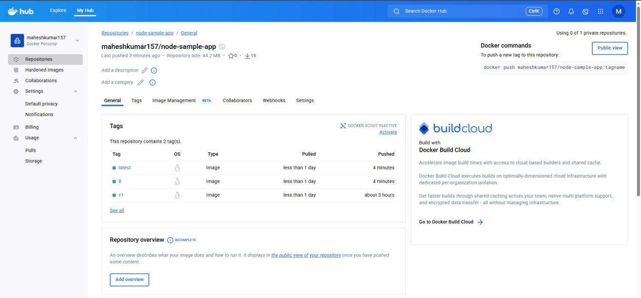

Note:

Instead of relying on Jenkins plugins, the following tools were installed directly inside the Jenkins container:

- - Node.js – for building and testing Node.js applications
- - Trivy – for scanning Docker images for vulnerabilities

These tools are installed at the OS level inside the Jenkins container, so pipeline steps can directly execute commands like npm install, docker build, docker push, and trivy image scan without requiring additional Jenkins plugins.

